Assignment 4

Unnamed PL/SQL code block: Use of Control structure and Exception handling is mandatory. Suggested Problem statement: Consider Tables: 1. Borrower(Roll_no, Name, DateofIssue, NameofBook, Status) 2. Fine(Roll_no,Date,Amt) • Accept Roll_no and NameofBook from user. • Check the number of days (from date of issue). • If days are between 15 to 30 then fine amount will be Rs 5per day. • If no. of days>30, per day fine will be Rs 50 per day and for days less than 30, Rs. 5 per day. • After submitting the book, status will change from I to R. • If condition of fine is true, then details will be stored into fine table. • Also handles the exception by named exception handler or user define exception handler.



Welcome to the MySQL monitor , Commands end with or

Your MySQL connection id is 11

Server version: 8 .34 MySQL Community Server — GPL

Copyright (c) 2000, 2023, Oracle and/or its affiliates .

Oracle is a registered trademark of Oracle Corporation and/or its affiliates . Other names may be trademarks of their respective owners .

Type ' help; ' or ' for help. Type ' to clear the current input sta tement .

mysql> use amit Database changed mysql> delimiter // mysql> create table borrower (roll no int, name varchar (20) , dateOI dater nameofbook varchar (20) , status varchar (20) ) ;

Query OK, 0 rows affected (C .15 sec)

mysql> insert into borrower values (IC , 'ram' , '2023-0901', 'xyz ' , 'Issued' ) ; //

Query OK, 1 row affected (0.07 sec)

mysql> insert into borrower values (12, ' rohan ' '2023-0903', 'issued' ) ; //

Query OK, 1 row affected (0.04 sec)

mysql> insert into borrower values (14, 'priya' , '2023-08 30', 'ABC ' , ' returned' ) ; //

Query OK, 1 row affected (27 .64 sec)

mysql> insert into borrower values (16, ' kunai '  ' 2023-0910', 'TOC' , 'returned' ) ; //

Query OK, 1 row affected (0.03 sec)

mysql> insert into borrower values (18, 'pat i I'  '2023-0912', 'up' , ' issued' ) ; //

Query 0K, 1 row affected (0.04 sec)

mysql> show tab les

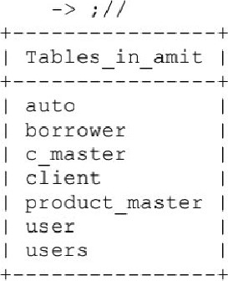

7 rows in set (0.00 sec)

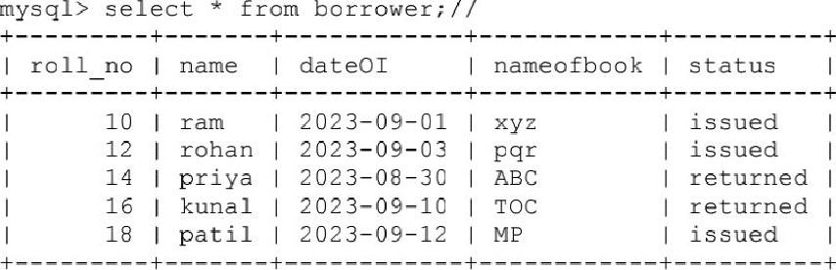

5 rows in set (0.00 sec)

mysgl> create table fine (roll no int, amt int) ; // Query OK, O rows affected (C .14 sec)

mysql> create procedure El (1011 new int, book name varchar (2 C) ) beg in declare x Integer; declare continue handler for not found begin

-> select 'NOT FOUND' ; end; select datediff (curdate C ) dateOI) into x from borrower where roll no=roll new;

-> if then insert into Fine values (roll new, curdate ( ) , (x* 50) ) ; end if; update borrower set status=' returned' where no=zcLL new; end;

Query OK, O rows affected, 1 warning (C .13 sec)

mysql> create table Fine (roll no int, dat date, amt int) ,

|  |  |
| --- | --- |
| Query OK, O | rows affected (C .22 sec) |
| mysgl> call | El (12, 'pgr' ) ; // |
| Query 0K, 1 | row affected (0.11 sec) |
| mysql> call | BI (1 C, 'xyz' ) ; // |
| Query 0K, 1 | row affected (0.07 sec) |
| mysgl> call | El (18, 'ME' ) ; // |
| Query 0K, 1 | row affected (0.07 sec) |

mysql> select from borrower;

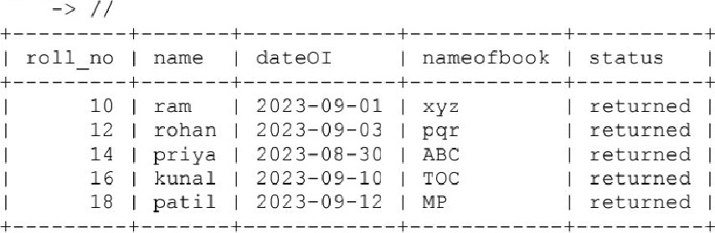

5 rows in set (0.00 sec)

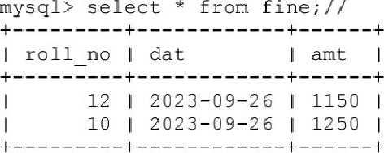

2 rows in set (0.00 sec)

mysql>